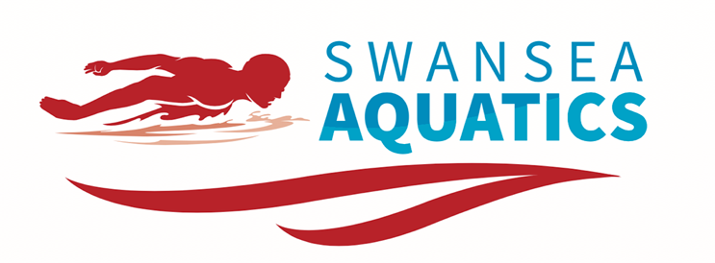

SWANSEA AQUATICS MAY OPEN MEET
FRIDAY 11 - SUNDAY 13 MAY 2018
WALES NATIONAL POOL SWANSEA

SESSION TIMES

FRIDAY 11 MAY 2018
SESSION | EVENTS | WARM UP | START
Session 1 | 1-5 | 8:00am | 9:00am
Session 2 | 6-10 | 11:30am | 12:30pm
Session 3 | FINALS | 3:15pm | 4:15pm

SATURDAY 12 MAY 2018
SESSION | EVENTS | WARM UP | START
Session 4 | 11-16 | 8:00am | 9:00am
Session 5 | 17-22 | 12:30am | 1:30pm
Session 6 | FINALS | 5:30pm | 6:15pm

SUNDAY 13 MAY 2018
SESSION | EVENTS | WARM UP | START
Session 7 | 23-27 | 8:00am | 9:00am
Session 8 | 28-32 | 11:15am | 12:15pm
Session 9 | FINALS | 2:45pm | 3:45pm

