REGISTERING FOR NEW SWANSEA AQUATICS STRUCTURE BY 31 MARCH 2018

As you are aware we are asking you to confirm that your athlete still wishes to swim with Swansea Aquatics from 1 April 2018. We’d also like you to check all of the information on your Swim Manager account to ensure this is kept fully up to date for re-registration of Swim Wales membership

To do this please follow the instructions below.

- Firstly click on the following link

https://www.active.com/swansea-swansea/water-sports/swimming-registrations/swansea-aquatics-19-season-2018

This will take you to the registration screen. Here you need to click the REGISTER NOW button

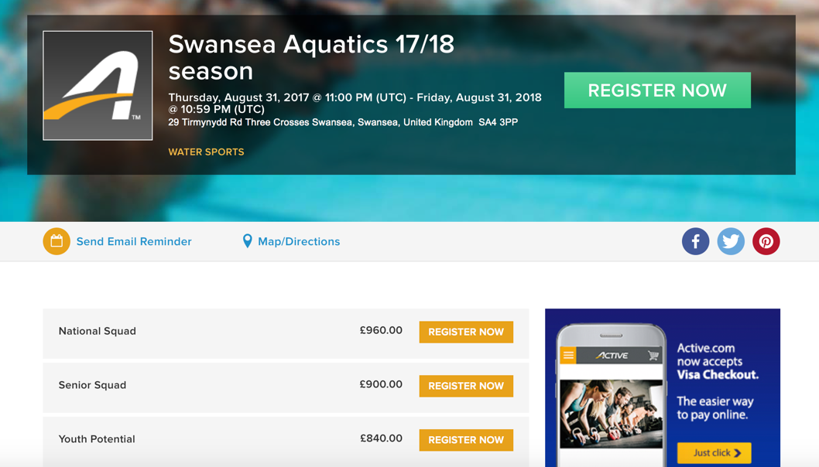

- The following screen may then appear, you just need to click close on this screen:

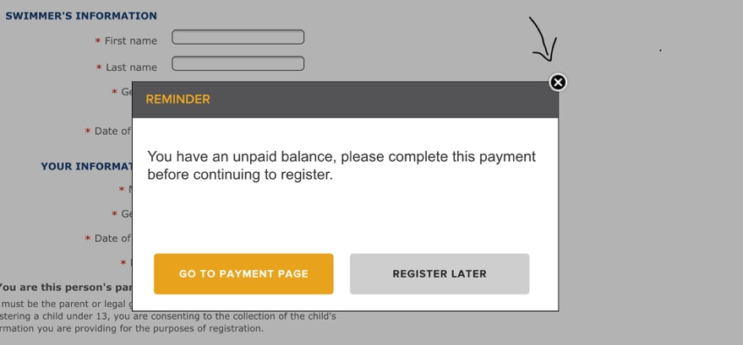

- This should then bring up the following screen that will show any athletes you already have registered in the system – Click your Child’s name (if you have more than one child in the club you can only do one at a time)
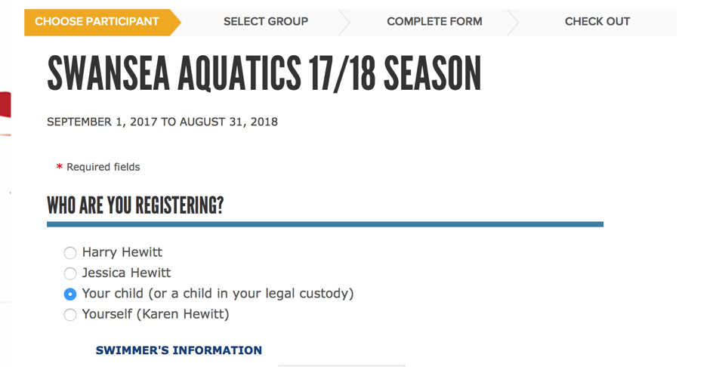

If the above screen doesn’t show – you will be taken to the screen below and should just log in using the details you use to log in to your Swim Portal

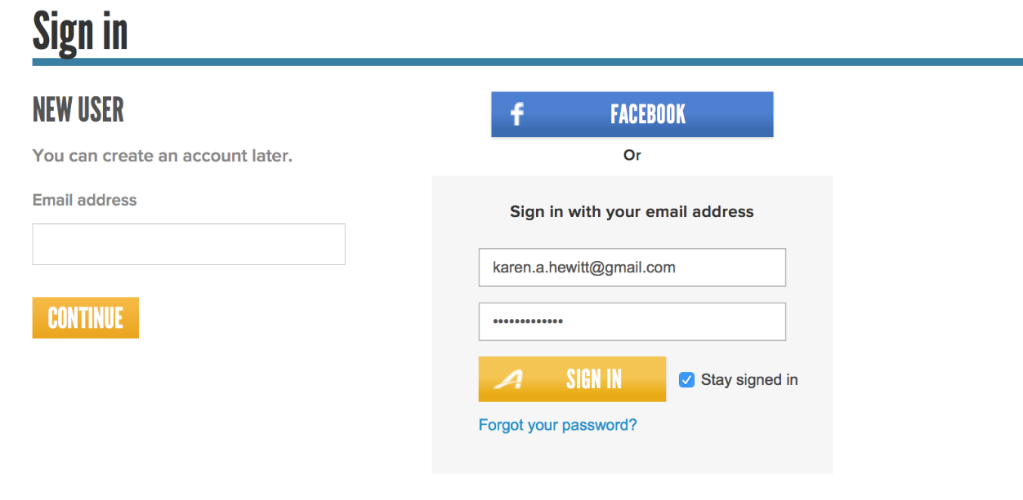

- The system will then ask you to clarify the squad for the new season so choose the relevant squad

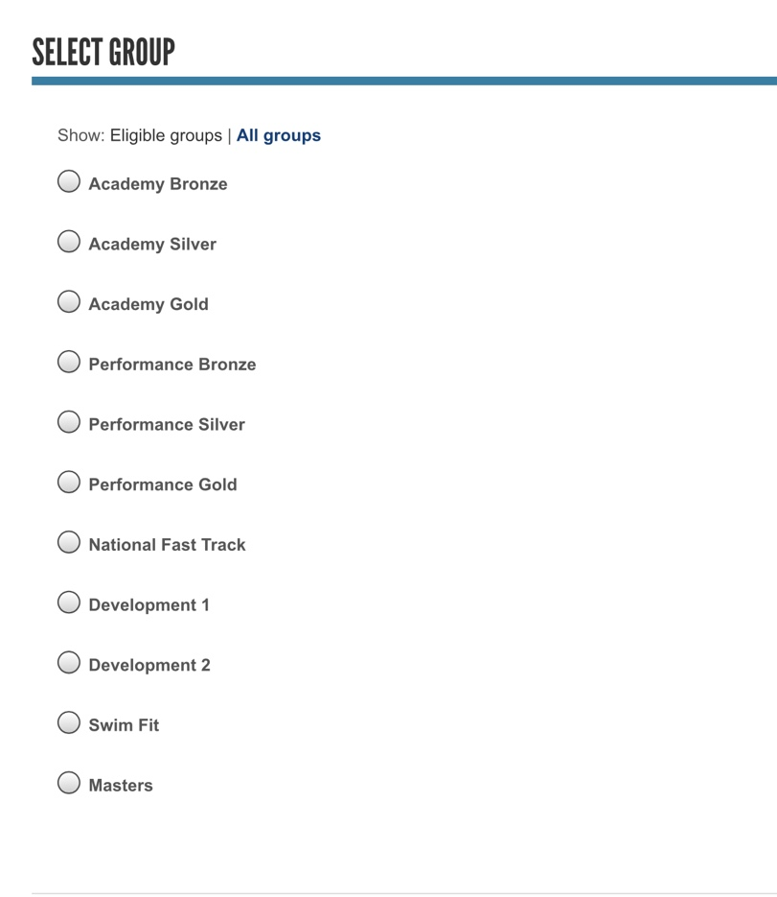

- The system will then bring up a registration form that will automatically populate all of the fields you entered when you initially registered and you just need to check all of the info on the form is correct. It may ask you to populate any missing information – country of representation and will also ask you to agree to the waivers again.

Could we also ask you to double check your swimmers DOB as we had a number of incorrect DOB’s input originally due to having your setting in US format. To change this you need to click the flag and change to British – top right of the screen as shown below:

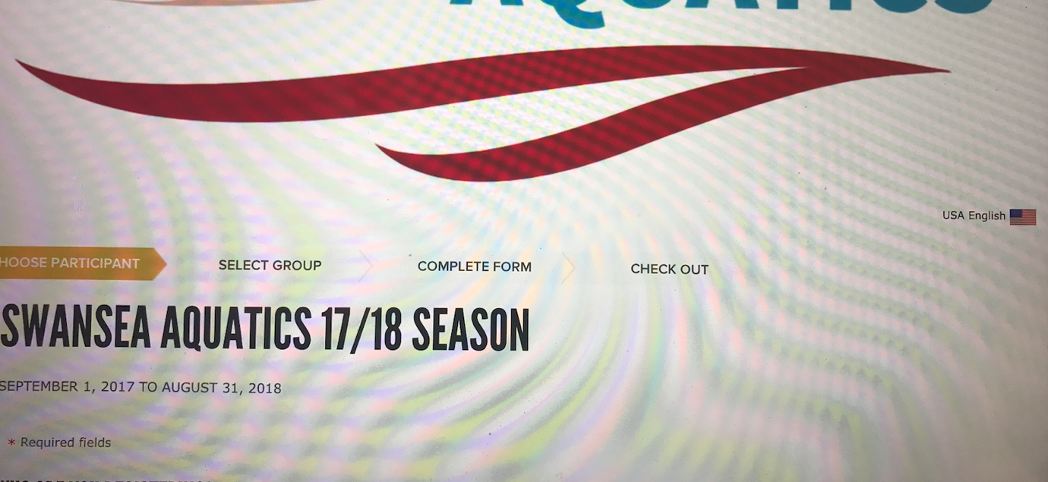

- Once you confirm the details and squad it will bring up a Review and Checkout screen as below.

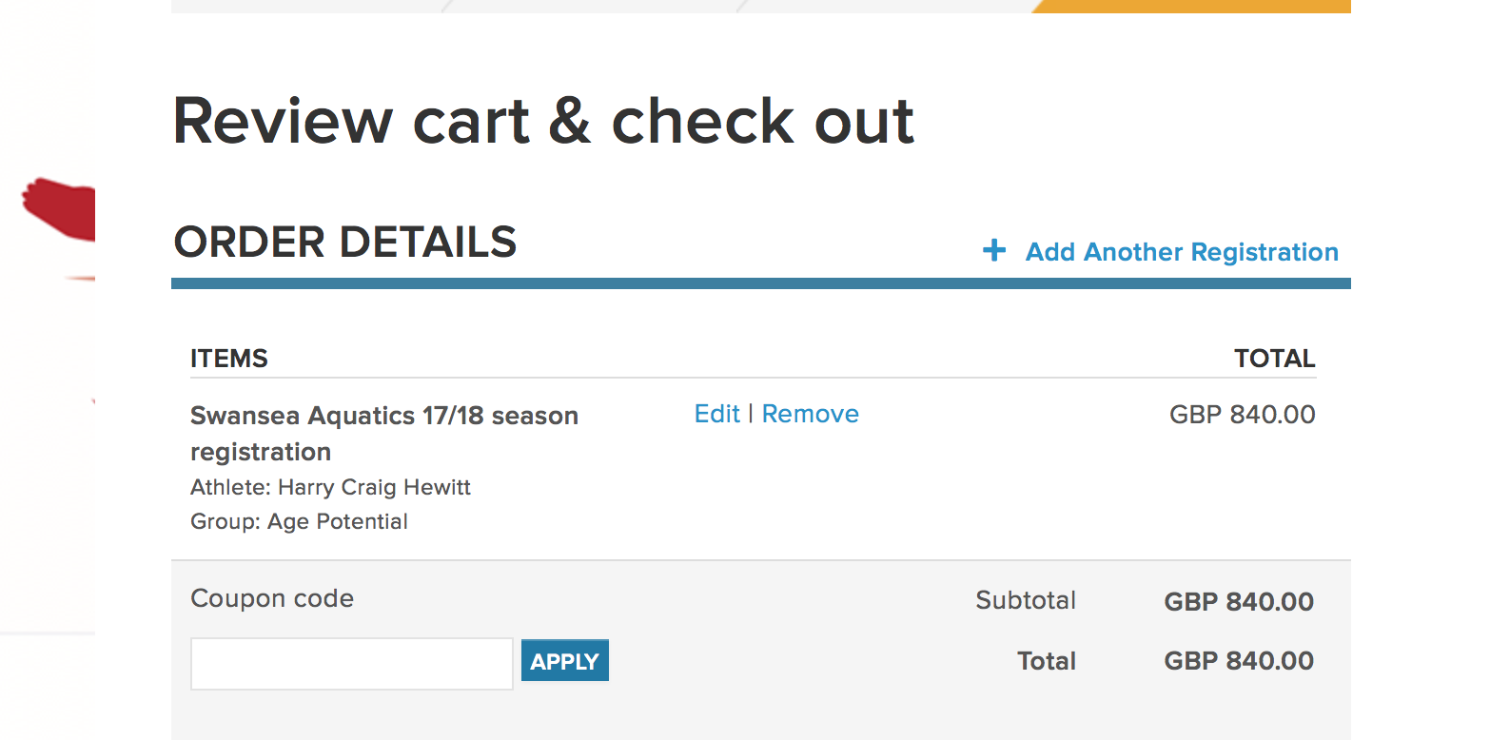

You should scroll down and choose the Payment plan option so it charges you in instalments. If you choose Pay in Full the whole annual squad fee will be charged so unless you want to pay like that please ensure you choose the option below.
It will also ask you to enter the 3 digit security code on the reverse of the card. You will also have the option to change your payment details here if you want to change the card you use to pay monthly fees.

You will also be required to pay the £50 membership charge at this stage and this is for Swim Wales annual membership and Swansea Aquatics annual membership and will last until 31 March 2019. This is a compulsory fee and has always been charged to members during March of every year.

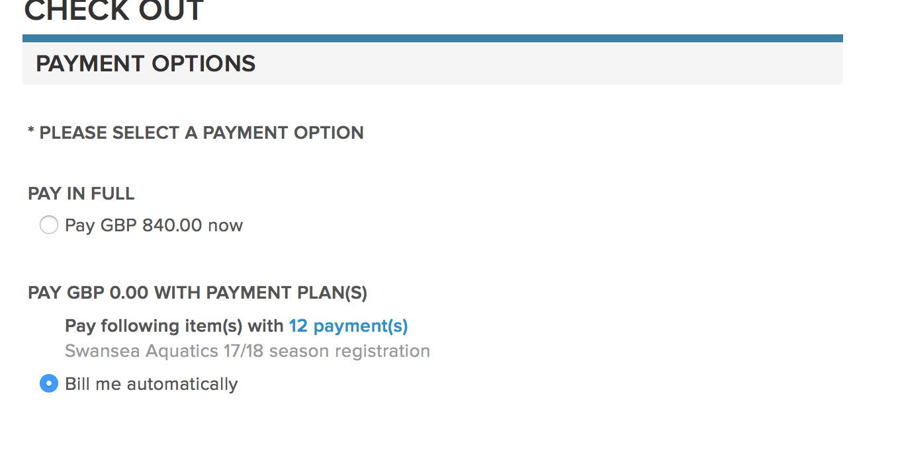

- Then choose complete on the screen shown below

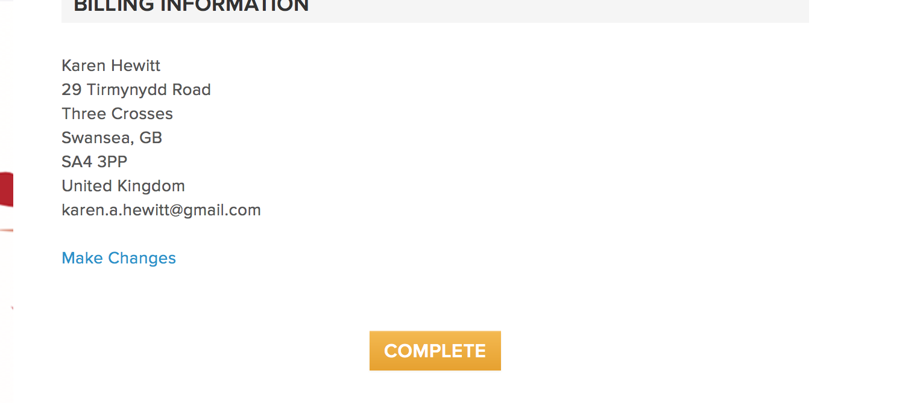
- YOU ARE NOW REGISTERED - AT THE NEXT SCRREN SCROLL ALL THE WAY TO THE BOTTOM UNTIL YOU SEE THE SCREEN BELOW, PLEASE DO NOT ENTER ANY INFO ON THIS PAGE AS IT IS A MARKETING OPTION!! JUST CLICK NO THANKS

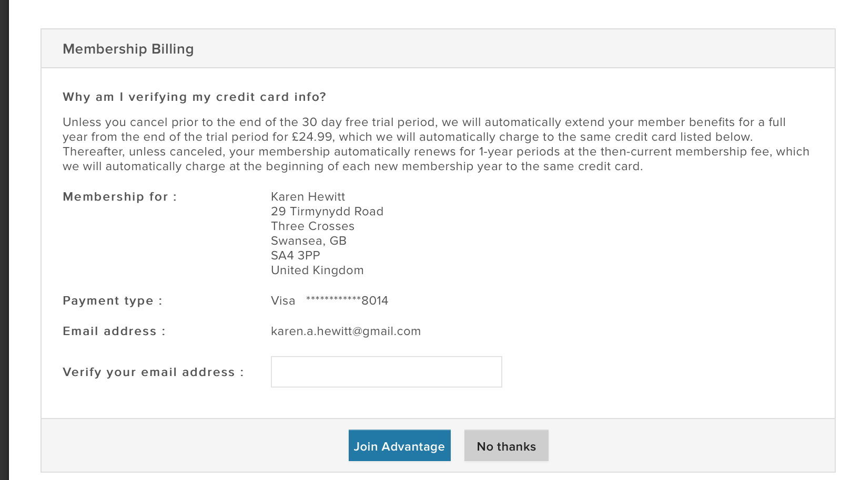

- If you now log in to your Swim Portal as you have been doing for the last few months you will see the new programme but all other information will be there as before including times, meet entries etc.

If you have any queries or problems, please email info.swanseaaquatics@gmail.com

