Swansea Aquatics Swimmers Qualify for the Commonwealth Games
Congratulations to five Swansea Aquatics swimmers who have qualified for the Gold Coast 2018 Commonwealth Games. Swansea Aquatics is the only swimming club in Wales to have this many swimmers going to GC2018 to represent their country!
The swimmers selected to represent Wales are Alex Rosser, Alys Thomas, Ellena Jones and Daniel Jervis. Jordan Gonzales has qualified to represent his country Gibraltar. All swimmers currently train at the Wales National Pool in Swansea.
These swimmers have been able to achieve their dreams because of their hard work, commitment and dedication to their sport. Swansea Aquatics Head Coach Hayley Baker has said the continued support from a great team of coaches, staff and Swim Wales has greatly attributed to their selection.

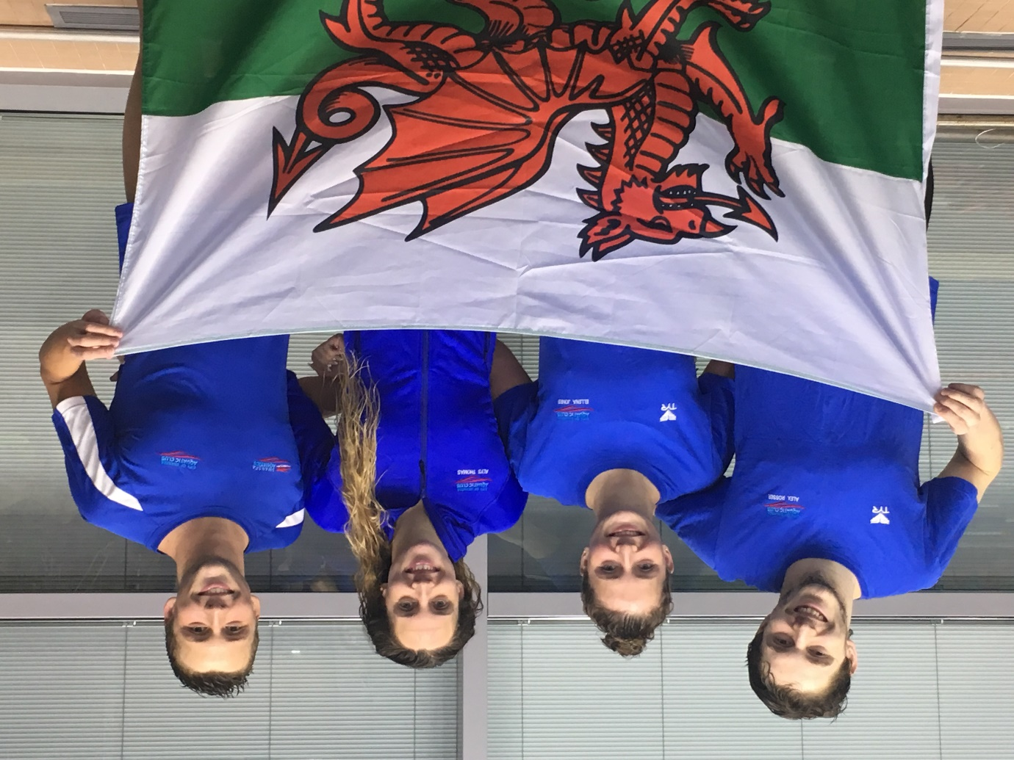
Selected to represent Wales
Left to Right
Swansea Aquatics swimmers Alex Rosser, Ellena Jones, Alys Thomas and Daniel Jervis

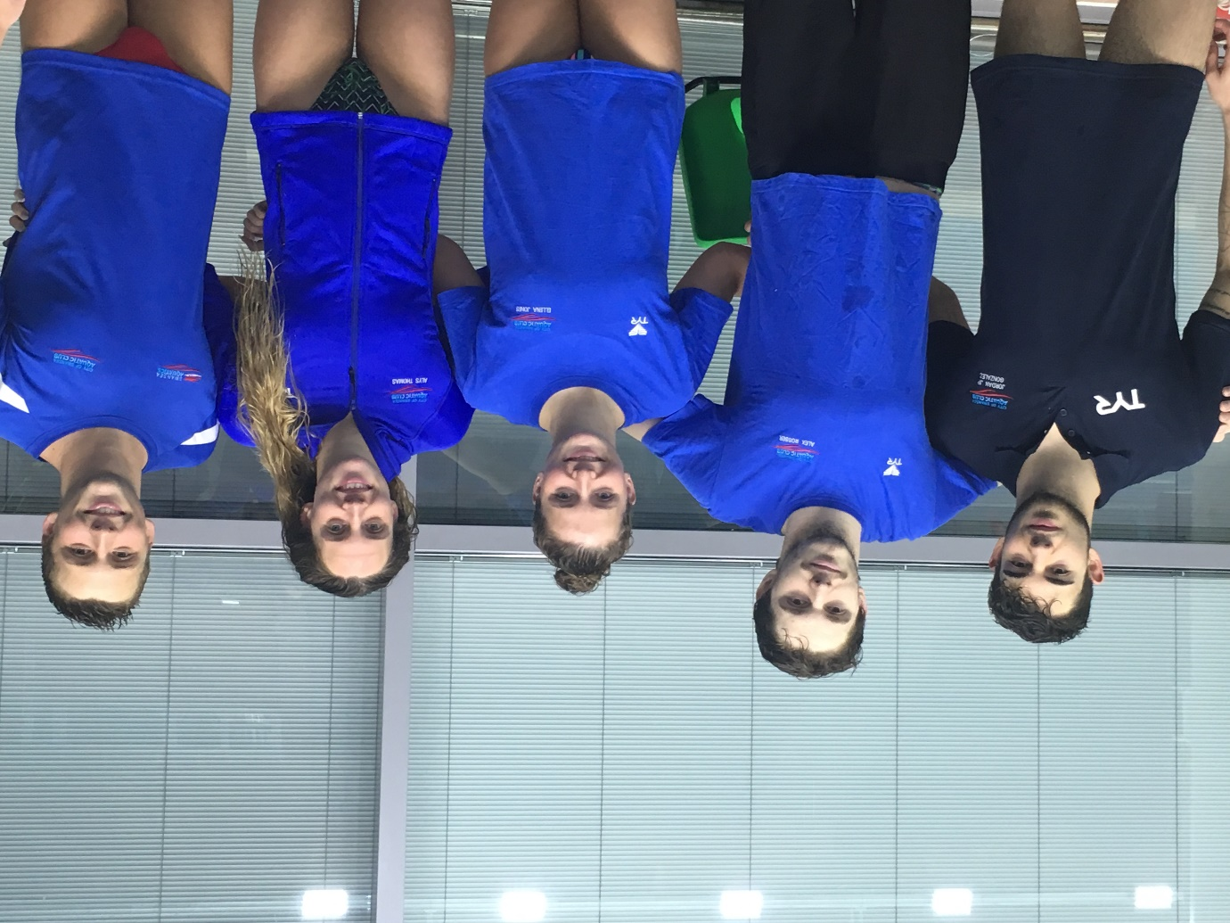
Jordan Gonzales (far left) with fellow Swansea Aquatics swimmers. Jordan will represent his country of Gibraltar at this year’s Commonwealth Games

